Advanced Git tutorials
Atlassian’s Git tutorials introduce the most common Git commands, and our Git Workflows modules discuss how these commands are typically used to facilitate collaboration. Alone, these are enough to get a development team up and running with Git. But, if you really want to leverage the full power of Git, you’re ready to dive into our Advanced Git articles.
Each of these articles provide an in-depth discussion of an advanced feature of Git. Instead of presenting new commands and concepts, they refine your existing Git skills by explaining what’s going on under the hood. Armed with this knowledge, you’ll be able to use familiar Git commands more effectively. More importantly, you’ll never be scared of breaking your Git repository because you’ll understand why it broke and how to fix it.

Merging vs. rebasing


Git is all about working with divergent history. Its git merge and git rebase commands offer alternative ways to integrate commits from different branches, and both options come with their own advantages. In this article, we’ll discuss how and when a basic git merge operation can be replaced with a rebase.
Learn more

Resetting, checking out, and reverting




related material

How to move a full Git repository
Read article


SEE SOLUTION

Learn Git with Bitbucket Cloud
Read tutorial
The git reset, git checkout, and git revert commands are all similar in that they undo some type of change in your repository. But, they all affect different combinations of the working directory, staged snapshot, and commit history. This article clearly defines how these commands differ and when each of them should be used in the standard Git workflows.
Learn more

Advanced Git log


The git log command is what makes your project history useful. Without it, you wouldn’t be able to access any of your commits. But, if you’re like most aspiring Git users, you’ve probably only scratched the surface of what’s possible with git log. This article walks you through its advanced formatting and filtering options, giving you the power to extract all sorts of interesting information from your Git repository.
Learn more

Git hooks


If you want to perform custom actions when a certain event takes place in a Git repository, hooks are your tool of choice. They let you normalize commit messages, automate testing suites, notify continuous integration systems, and much more. After this article, you’ll understand the many ways in which Git hooks can streamline your workflow.
Learn more

Refs and the reflog


A ref is Git’s internal way of referring to a commit. You’re already familiar with many categories of refs, including commit hashes and branch names. But, there are many other types of refs, and virtually every Git command utilizes them in some form or another. You’ll walk away from this article with an intimate knowledge of Git’s inner workings.

Merging vs. rebasing
The git rebase command has a reputation for being magical Git hocus pocus that beginners should stay away from, but it can actually make life much easier for a development team when used with care. In this article, we’ll compare git rebase with the related git merge command and identify all of the potential opportunities to incorporate rebasing into the typical Git workflow.

Conceptual overview

The first thing to understand about git rebase is that it solves the same problem as git merge. Both of these commands are designed to integrate changes from one branch into another branch—they just do it in very different ways.
Consider what happens when you start working on a new feature in a dedicated branch, then another team member updates the main branch with new commits. This results in a forked history, which should be familiar to anyone who has used Git as a collaboration tool.
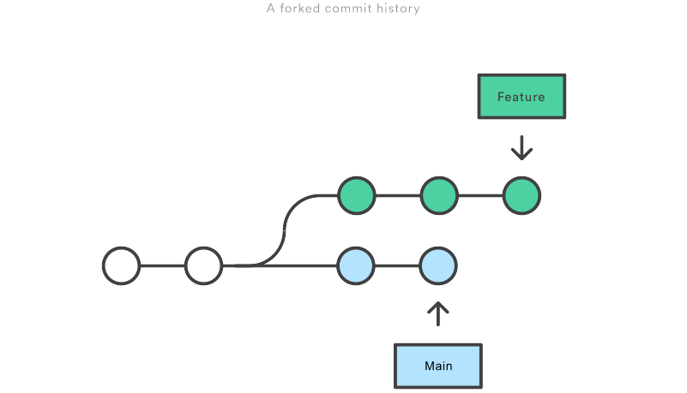
Now, let’s say that the new commits in main are relevant to the feature that you’re working on. To incorporate the new commits into your feature branch, you have two options: merging or rebasing.

related material

How to move a full Git repository
Read article

SEE SOLUTION

Learn Git with Bitbucket Cloud
Read tutorial

The merge option
The easiest option is to merge the main branch into the feature branch using something like the following:
git checkout feature
git merge main
Or, you can condense this to a one-liner:
git merge feature main
This creates a new “merge commit” in the feature branch that ties together the histories of both branches, giving you a branch structure that looks like this:
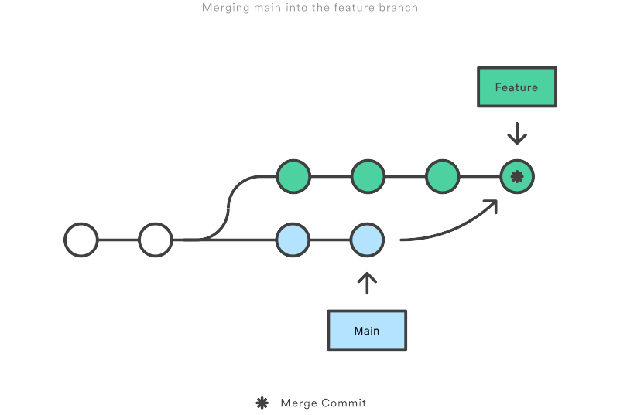
Merging is nice because it’s a non-destructive operation. The existing branches are not changed in any way. This avoids all of the potential pitfalls of rebasing (discussed below).
On the other hand, this also means that the feature branch will have an extraneous merge commit every time you need to incorporate upstream changes. If main is very active, this can pollute your feature branch’s history quite a bit. While it’s possible to mitigate this issue with advanced git log options, it can make it hard for other developers to understand the history of the project.

The rebase option
As an alternative to merging, you can rebase the feature branch onto main branch using the following commands:
git checkout feature
git rebase main
This moves the entire feature branch to begin on the tip of the main branch, effectively incorporating all of the new commits in main. But, instead of using a merge commit, rebasing re-writes the project history by creating brand new commits for each commit in the original branch.
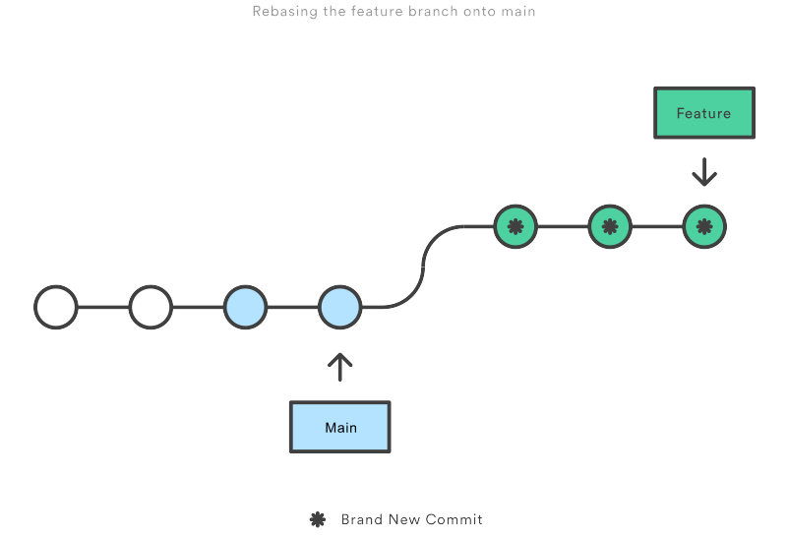
The major benefit of rebasing is that you get a much cleaner project history. First, it eliminates the unnecessary merge commits required by git merge. Second, as you can see in the above diagram, rebasing also results in a perfectly linear project history—you can follow the tip of feature all the way to the beginning of the project without any forks. This makes it easier to navigate your project with commands like git log, git bisect, and gitk.
But, there are two trade-offs for this pristine commit history: safety and traceability. If you don’t follow the Golden Rule of Rebasing, re-writing project history can be potentially catastrophic for your collaboration workflow. And, less importantly, rebasing loses the context provided by a merge commit—you can’t see when upstream changes were incorporated into the feature.

Interactive rebasing
Interactive rebasing gives you the opportunity to alter commits as they are moved to the new branch. This is even more powerful than an automated rebase, since it offers complete control over the branch’s commit history. Typically, this is used to clean up a messy history before merging a feature branch into main.
To begin an interactive rebasing session, pass the i option to the git rebase command:
git checkout feature
git rebase -i main
This will open a text editor listing all of the commits that are about to be moved:
pick 33d5b7a Message for commit #1
pick 9480b3d Message for commit #2
pick 5c67e61 Message for commit #3
This listing defines exactly what the branch will look like after the rebase is performed. By changing the pick command and/or re-ordering the entries, you can make the branch’s history look like whatever you want. For example, if the 2nd commit fixes a small problem in the 1st commit, you can condense them into a single commit with the fixup command:
pick 33d5b7a Message for commit #1
fixup 9480b3d Message for commit #2
pick 5c67e61 Message for commit #3
When you save and close the file, Git will perform the rebase according to your instructions, resulting in project history that looks like the following:
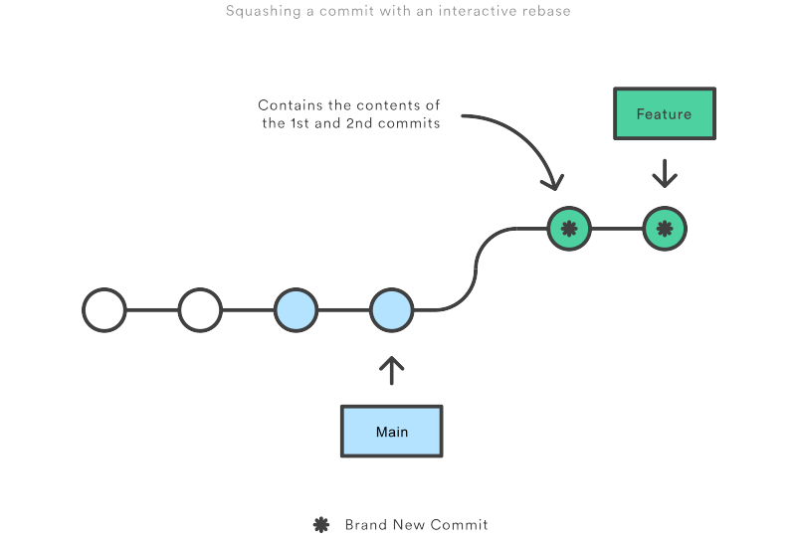
Eliminating insignificant commits like this makes your feature’s history much easier to understand. This is something that git merge simply cannot do.

The golden rule of rebasing

Once you understand what rebasing is, the most important thing to learn is when not to do it. The golden rule of git rebase is to never use it on public branches.
For example, think about what would happen if you rebased main onto your feature branch:
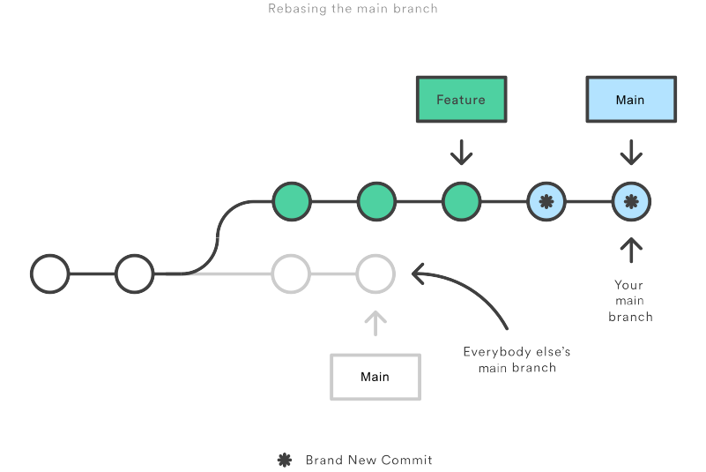
The rebase moves all of the commits in main onto the tip of feature. The problem is that this only happened in your repository. All of the other developers are still working with the original main. Since rebasing results in brand new commits, Git will think that your main branch’s history has diverged from everybody else’s.
The only way to synchronize the two main branches is to merge them back together, resulting in an extra merge commit and two sets of commits that contain the same changes (the original ones, and the ones from your rebased branch). Needless to say, this is a very confusing situation.
So, before you run git rebase, always ask yourself, “Is anyone else looking at this branch?” If the answer is yes, take your hands off the keyboard and start thinking about a non-destructive way to make your changes (e.g., the git revert command). Otherwise, you’re safe to re-write history as much as you like.

Force-pushing
If you try to push the rebased main branch back to a remote repository, Git will prevent you from doing so because it conflicts with the remote main branch. But, you can force the push to go through by passing the --force flag, like so:
# Be very careful with this command! git push --force
This overwrites the remote main branch to match the rebased one from your repository and makes things very confusing for the rest of your team. So, be very careful to use this command only when you know exactly what you’re doing.
One of the only times you should be force-pushing is when you’ve performed a local cleanup after you’ve pushed a private feature branch to a remote repository (e.g., for backup purposes). This is like saying, “Oops, I didn’t really want to push that original version of the feature branch. Take the current one instead.” Again, it’s important that nobody is working off of the commits from the original version of the feature branch.

Workflow walkthrough

Rebasing can be incorporated into your existing Git workflow as much or as little as your team is comfortable with. In this section, we’ll take a look at the benefits that rebasing can offer at the various stages of a feature’s development.
The first step in any workflow that leverages git rebase is to create a dedicated branch for each feature. This gives you the necessary branch structure to safely utilize rebasing:
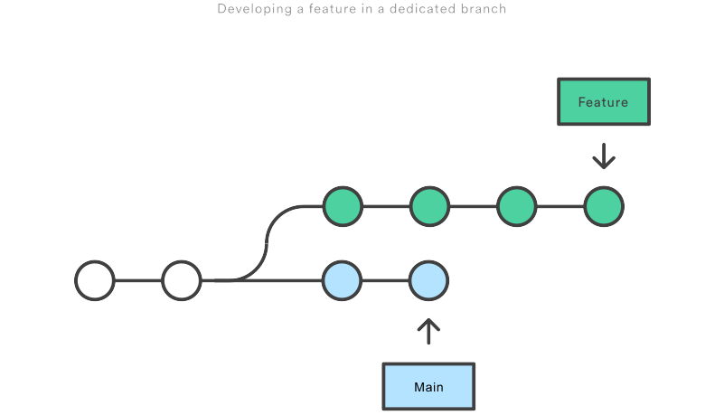

Local cleanup
One of the best ways to incorporate rebasing into your workflow is to clean up local, in-progress features. By periodically performing an interactive rebase, you can make sure each commit in your feature is focused and meaningful. This lets you write your code without worrying about breaking it up into isolated commits—you can fix it up after the fact.
When calling git rebase, you have two options for the new base: The feature’s parent branch (e.g., main), or an earlier commit in your feature. We saw an example of the first option in the Interactive Rebasing section. The latter option is nice when you only need to fix up the last few commits. For example, the following command begins an interactive rebase of only the last 3 commits.
git checkout feature git rebase -i HEAD~3
By specifying HEAD~3 as the new base, you’re not actually moving the branch—you’re just interactively re-writing the 3 commits that follow it. Note that this will not incorporate upstream changes into the feature branch.
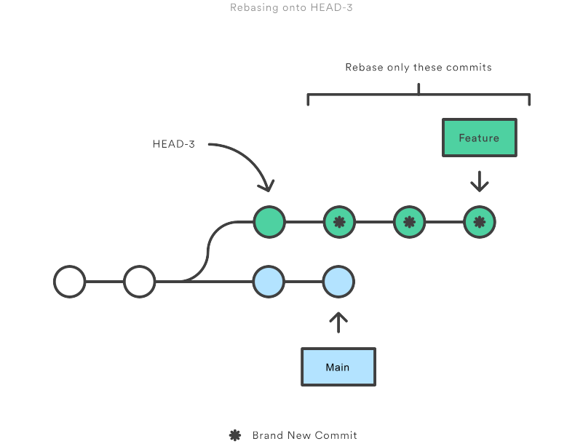
If you want to re-write the entire feature using this method, the git merge-base command can be useful to find the original base of the feature branch. The following returns the commit ID of the original base, which you can then pass to git rebase:
git merge-base feature main
This use of interactive rebasing is a great way to introduce git rebase into your workflow, as it only affects local branches. The only thing other developers will see is your finished product, which should be a clean, easy-to-follow feature branch history.
But again, this only works for private feature branches. If you’re collaborating with other developers via the same feature branch, that branch is public, and you’re not allowed to re-write its history.
There is no git merge alternative for cleaning up local commits with an interactive rebase.

Incorporating upstream changes into a feature
In the Conceptual Overview section, we saw how a feature branch can incorporate upstream changes from main using either git merge or git rebase. Merging is a safe option that preserves the entire history of your repository, while rebasing creates a linear history by moving your feature branch onto the tip of main.
This use of git rebase is similar to a local cleanup (and can be performed simultaneously), but in the process it incorporates those upstream commits from main.
Keep in mind that it’s perfectly legal to rebase onto a remote branch instead of main. This can happen when collaborating on the same feature with another developer and you need to incorporate their changes into your repository.
For example, if you and another developer named John added commits to the feature branch, your repository might look like the following after fetching the remote feature branch from John’s repository:
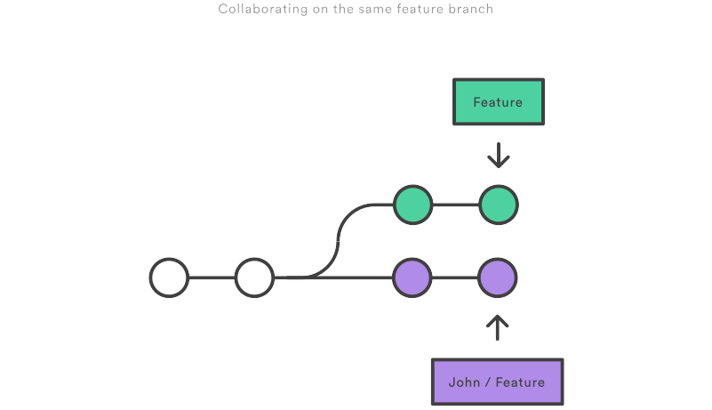
You can resolve this fork the exact same way as you integrate upstream changes from main: either merge your local feature with john/feature, or rebase your local feature onto the tip of john/feature.
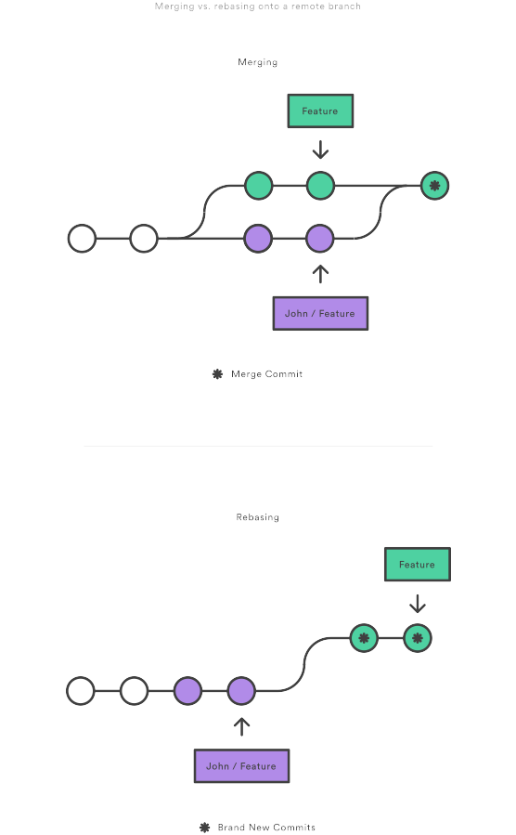
Note that this rebase doesn’t violate the Golden Rule of Rebasing because only your local feature commits are being moved—everything before that is untouched. This is like saying, “add my changes to what John has already done.” In most circumstances, this is more intuitive than synchronizing with the remote branch via a merge commit.
By default, the git pull command performs a merge, but you can force it to integrate the remote branch with a rebase by passing it the --rebase option.

Reviewing a feature with a pull request
If you use pull requests as part of your code review process, you need to avoid using git rebase after creating the pull request. As soon as you make the pull request, other developers will be looking at your commits, which means that it’s a public branch. Re-writing its history will make it impossible for Git and your teammates to track any follow-up commits added to the feature.
Any changes from other developers need to be incorporated with git merge instead of git rebase.
For this reason, it’s usually a good idea to clean up your code with an interactive rebase before submitting your pull request.

Integrating an approved feature
After a feature has been approved by your team, you have the option of rebasing the feature onto the tip of the main branch before using git merge to integrate the feature into the main code base.
This is a similar situation to incorporating upstream changes into a feature branch, but since you’re not allowed to re-write commits in the main branch, you have to eventually use git merge to integrate the feature. However, by performing a rebase before the merge, you’re assured that the merge will be fast-forwarded, resulting in a perfectly linear history. This also gives you the chance to squash any follow-up commits added during a pull request.
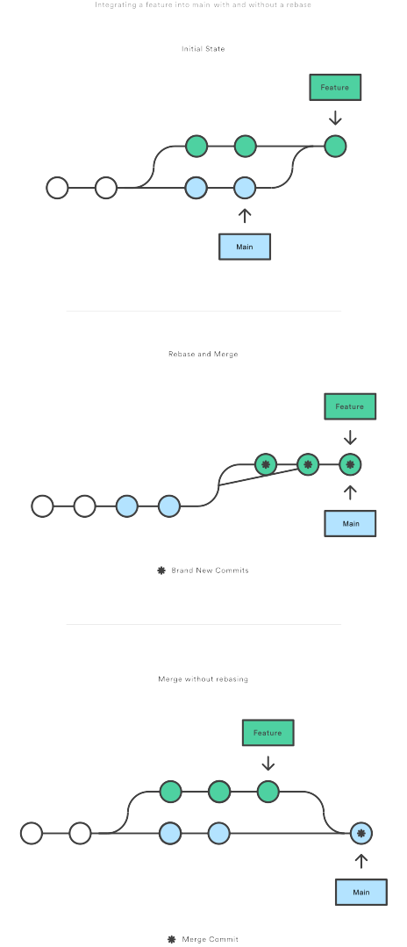
If you’re not entirely comfortable with git rebase, you can always perform the rebase in a temporary branch. That way, if you accidentally mess up your feature’s history, you can check out the original branch and try again. For example:
git checkout feature
git checkout -b temporary-branch
git rebase -i main
# [Clean up the history]
git checkout main
git merge temporary-branch

Summary

And that’s all you really need to know to start rebasing your branches. If you would prefer a clean, linear history free of unnecessary merge commits, you should reach for git rebase instead of git merge when integrating changes from another branch.
On the other hand, if you want to preserve the complete history of your project and avoid the risk of re-writing public commits, you can stick with git merge. Either option is perfectly valid, but at least now you have the option of leveraging the benefits of git rebase.

Resetting, checking out & reverting

The git reset, git checkout, and git revert commands are some of the most useful tools in your Git toolbox. They all let you undo some kind of change in your repository, and the first two commands can be used to manipulate either commits or individual files.
Because they’re so similar, it’s very easy to mix up which command should be used in any given development scenario. In this article, we’ll compare the most common configurations of git reset, git checkout, and git revert. Hopefully, you’ll walk away with the confidence to navigate your repository using any of these commands.
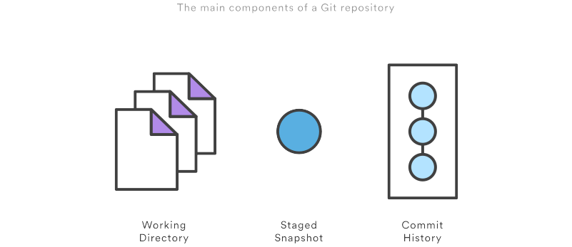
It helps to think about each command in terms of their effect on the three state management mechanisms of a Git repository: the working directory, the staged snapshot, and the commit history. These components are sometimes known as "The three trees" of Git. We explore the three trees in depth on the git reset page. Keep these mechanisms in mind as you read through this article.
A checkout is an operation that moves the HEAD ref pointer to a specified commit. To demonstrate this consider the following example.
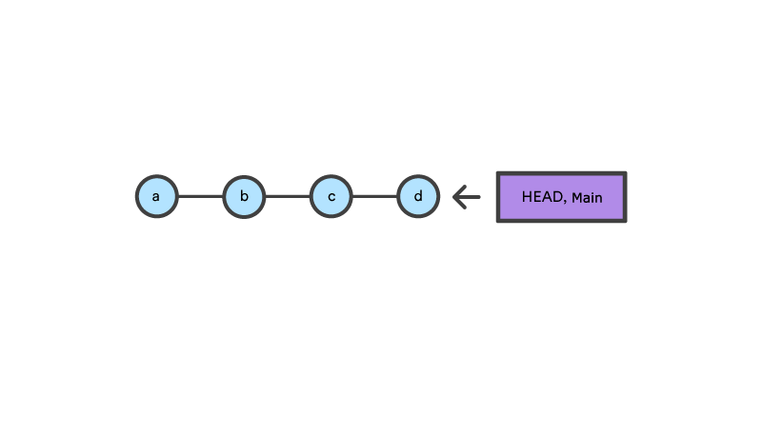

related material

How to move a full Git repository
Read article

SEE SOLUTION

Learn Git with Bitbucket Cloud
Read tutorial
This example demonstrates a sequence of commits on the main branch. The HEAD ref and main branch ref currently point to commit d. Now let us execute git checkout b
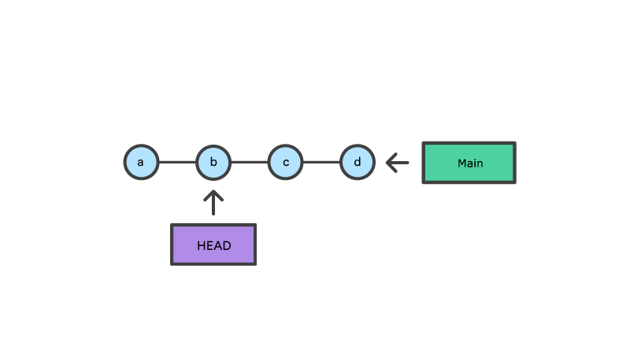
This is an update to the "Commit History" tree. The git checkout command can be used in a commit, or file level scope. A file level checkout will change the file's contents to those of the specific commit.
A revert is an operation that takes a specified commit and creates a new commit which inverses the specified commit. git revert can only be run at a commit level scope and has no file level functionality.
A reset is an operation that takes a specified commit and resets the "three trees" to match the state of the repository at that specified commit. A reset can be invoked in three different modes which correspond to the three trees.
Checkout and reset are generally used for making local or private 'undos'. They modify the history of a repository that can cause conflicts when pushing to remote shared repositories. Revert is considered a safe operation for 'public undos' as it creates new history which can be shared remotely and doesn't overwrite history remote team members may be dependent on.

Git reset vs revert vs checkout reference

The table below sums up the most common use cases for all of these commands. Be sure to keep this reference handy, as you’ll undoubtedly need to use at least some of them during your Git career.

Command | Scope | Common use cases
git reset | Commit-level | Discard commits in a private branch or throw away uncommitted changes
git reset | File-level | Unstage a file
git checkout | Commit-level | Switch between branches or inspect old snapshots
git checkout | File-level | Discard changes in the working directory
git revert | Commit-level | Undo commits in a public branch
git revert | File-level | (N/A)

Commit level operations

The parameters that you pass to git reset and git checkout determine their scope. When you don’t include a file path as a parameter, they operate on whole commits. That’s what we’ll be exploring in this section. Note that git revert has no file-level counterpart.

Reset a specific commit
On the commit-level, resetting is a way to move the tip of a branch to a different commit. This can be used to remove commits from the current branch. For example, the following command moves the hotfix branch backwards by two commits.
git checkout hotfix git reset HEAD~2
The two commits that were on the end of hotfix are now dangling, or orphaned commits. This means they will be deleted the next time Git performs a garbage collection. In other words, you’re saying that you want to throw away these commits. This can be visualized as the following:

This usage of git reset is a simple way to undo changes that haven’t been shared with anyone else. It’s your go-to command when you’ve started working on a feature and find yourself thinking, “Oh crap, what am I doing? I should just start over.”
In addition to moving the current branch, you can also get git reset to alter the staged snapshot and/or the working directory by passing it one of the following flags:
- --soft – The staged snapshot and working directory are not altered in any way.
- --mixed – The staged snapshot is updated to match the specified commit, but the working directory is not affected. This is the default option.
- --hard – The staged snapshot and the working directory are both updated to match the specified commit.
It’s easier to think of these modes as defining the scope of a git reset operation. For further detailed information visit the git reset page.

Checkout old commits
The git checkout command is used to update the state of the repository to a specific point in the projects history. When passed with a branch name, it lets you switch between branches.
git checkout hotfix
Internally, all the above command does is move HEAD to a different branch and update the working directory to match. Since this has the potential to overwrite local changes, Git forces you to commit or stash any changes in the working directory that will be lost during the checkout operation. Unlike git reset, git checkout doesn’t move any branches around.

You can also check out arbitrary commits by passing the commit reference instead of a branch. This does the exact same thing as checking out a branch: it moves the HEAD reference to the specified commit. For example, the following command will check out the grandparent of the current commit:
git checkout HEAD~2
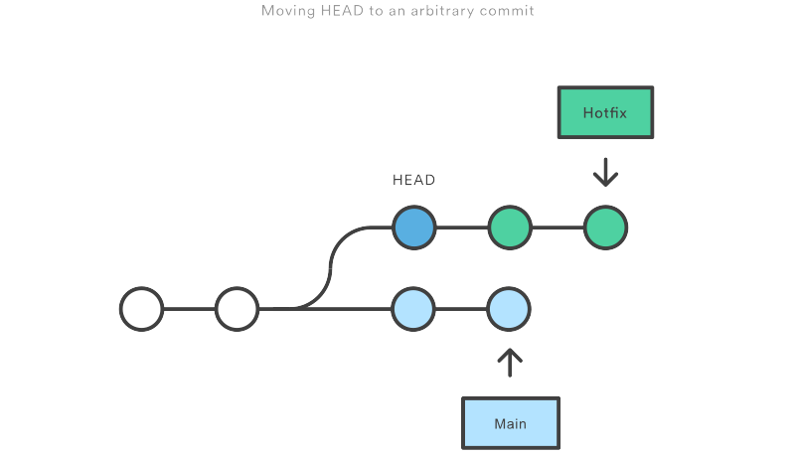
This is useful for quickly inspecting an old version of your project. However, since there is no branch reference to the current HEAD, this puts you in a detached HEAD state. This can be dangerous if you start adding new commits because there will be no way to get back to them after you switch to another branch. For this reason, you should always create a new branch before adding commits to a detached HEAD.

Undo public commits with revert
Reverting undoes a commit by creating a new commit. This is a safe way to undo changes, as it has no chance of re-writing the commit history. For example, the following command will figure out the changes contained in the 2nd to last commit, create a new commit undoing those changes, and tack the new commit onto the existing project.
git checkout hotfix git revert HEAD~2
This can be visualized as the following:
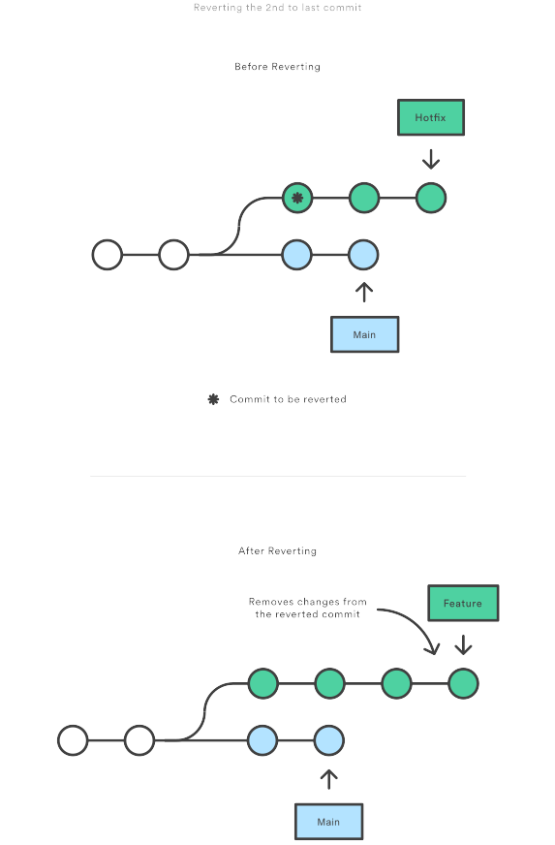
Contrast this with git reset, which does alter the existing commit history. For this reason, git revert should be used to undo changes on a public branch, and git reset should be reserved for undoing changes on a private branch.
You can also think of git revert as a tool for undoing committed changes, while git reset HEAD is for undoing uncommitted changes.
Like git checkout, git revert has the potential to overwrite files in the working directory, so it will ask you to commit or stash changes that would be lost during the revert operation.

File-level operations

The git reset and git checkout commands also accept an optional file path as a parameter. This dramatically alters their behavior. Instead of operating on entire snapshots, this forces them to limit their operations to a single file.

Git reset a specific file
When invoked with a file path, git reset updates the staged snapshot to match the version from the specified commit. For example, this command will fetch the version of foo.py in the 2nd-to-last commit and stage it for the next commit:
git reset HEAD~2 foo.py
As with the commit-level version of git reset, this is more commonly used with HEAD rather than an arbitrary commit. Running git reset HEAD foo.py will unstage foo.py. The changes it contains will still be present in the working directory.
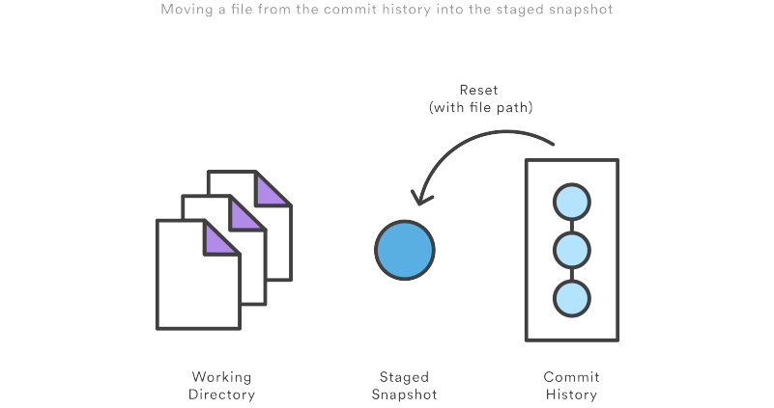
The --soft, --mixed, and --hard flags do not have any effect on the file-level version of git reset, as the staged snapshot is always updated, and the working directory is never updated.

Git checkout file
Checking out a file is similar to using git reset with a file path, except it updates the working directory instead of the stage. Unlike the commit-level version of this command, this does not move the HEAD reference, which means that you won’t switch branches.
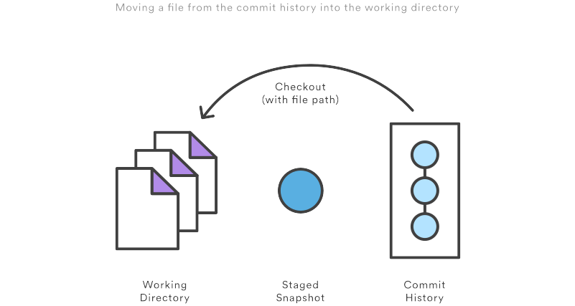
For example, the following command makes foo.py in the working directory match the one from the 2nd-to-last commit:
git checkout HEAD~2 foo.py
Just like the commit-level invocation of git checkout, this can be used to inspect old versions of a project—but the scope is limited to the specified file.
If you stage and commit the checked-out file, this has the effect of “reverting” to the old version of that file. Note that this removes all of the subsequent changes to the file, whereas the git revert command undoes only the changes introduced by the specified commit.
Like git reset, this is commonly used with HEAD as the commit reference. For instance, git checkout HEAD foo.py has the effect of discarding unstaged changes to foo.py. This is similar behavior to git reset HEAD --hard, but it operates only on the specified file.

Summary

You should now have all the tools you could ever need to undo changes in a Git repository. The git reset, git checkout, and git revert commands can be confusing, but when you think about their effects on the working directory, staged snapshot, and commit history, it should be easier to discern which command fits the development task at hand.

Advanced Git log
The purpose of any version control system is to record changes to your code. This gives you the power to go back into your project history to see who contributed what, figure out where bugs were introduced, and revert problematic changes. But, having all of this history available is useless if you don’t know how to navigate it. That’s where the git log command comes in.
By now, you should already know the basic git log command for displaying commits. But, you can alter this output by passing many different parameters to git log.
The advanced features of git log can be split into two categories: formatting how each commit is displayed, and filtering which commits are included in the output. Together, these two skills give you the power to go back into your project and find any information that you could possibly need.

Formatting log output

First, this article will take a look at the many ways in which git log’s output can be formatted. Most of these come in the form of flags that let you request more or less information from git log.
If you don’t like the default git log format, you can use git config’s aliasing functionality to create a shortcut for any of the formatting options discussed below. Please see in The git config Command for how to set up an alias.

Oneline
The --oneline flag condenses each commit to a single line. By default, it displays only the commit ID and the first line of the commit message. Your typical git log --oneline output will look something like this:
0e25143 Merge branch 'feature'
ad8621a Fix a bug in the feature
16b36c6 Add a new feature
23ad9ad Add the initial code base
This is very useful for getting a high-level overview of your project.

related material

How to move a full Git repository
Read article

SEE SOLUTION

Learn Git with Bitbucket Cloud
Read tutorial

Decorating
Many times it’s useful to know which branch or tag each commit is associated with. The --decorate flag makes git log display all of the references (e.g., branches, tags, etc) that point to each commit.
This can be combined with other configuration options. For example, running git log --oneline --decorate will format the commit history like so:
0e25143 (HEAD, main) Merge branch 'feature'
ad8621a (feature) Fix a bug in the feature
16b36c6 Add a new feature
23ad9ad (tag: v0.9) Add the initial code base
This lets you know that the top commit is also checked out (denoted by HEAD) and that it is also the tip of the main branch. The second commit has another branch pointing to it called feature, and finally the 4th commit is tagged as v0.9.
Branches, tags, HEAD, and the commit history are almost all of the information contained in your Git repository, so this gives you a more complete view of the logical structure of your repository.

Diffs
The git log command includes many options for displaying diffs with each commit. Two of the most common options are --stat and -p.
The --stat option displays the number of insertions and deletions to each file altered by each commit (note that modifying a line is represented as 1 insertion and 1 deletion). This is useful when you want a brief summary of the changes introduced by each commit. For example, the following commit added 67 lines to the hello.py file and removed 38 lines:
commit f2a238924e89ca1d4947662928218a06d39068c3
Author: John <john@example.com>
Date: Fri Jun 25 17:30:28 2014 -0500

Add a new feature

hello.py | 105 ++++++++++++++++++++++++-----------------
1 file changed, 67 insertion(+), 38 deletions(-)
The amount of + and - signs next to the file name show the relative number of changes to each file altered by the commit. This gives you an idea of where the changes for each commit can be found.
If you want to see the actual changes introduced by each commit, you can pass the -p option to git log. This outputs the entire patch representing that commit:
commit 16b36c697eb2d24302f89aa22d9170dfe609855b
Author: Mary <mary@example.com>
Date: Fri Jun 25 17:31:57 2014 -0500

Fix a bug in the feature

diff --git a/hello.py b/hello.py
index 18ca709..c673b40 100644
--- a/hello.py
+++ b/hello.py
@@ -13,14 +13,14 @@ B
-print("Hello, World!")
+print("Hello, Git!")
For commits with a lot of changes, the resulting output can become quite long and unwieldy. More often than not, if you’re displaying a full patch, you’re probably searching for a specific change. For this, you want to use the pickaxe option.

The shortlog
The git shortlog command is a special version of git log intended for creating release announcements. It groups each commit by author and displays the first line of each commit message. This is an easy way to see who’s been working on what.
For example, if two developers have contributed 5 commits to a project, the git shortlog output might look like the following:
Mary (2):
Fix a bug in the feature
Fix a serious security hole in our framework

John (3):
Add the initial code base
Add a new feature
Merge branch 'feature'
By default, git shortlog sorts the output by author name, but you can also pass the -n option to sort by the number of commits per author.

Graphs
The --graph option draws an ASCII graph representing the branch structure of the commit history. This is commonly used in conjunction with the --oneline and --decorate commands to make it easier to see which commit belongs to which branch:
git log --graph --oneline --decorate
For a simple repository with just 2 branches, this will produce the following:
* 0e25143 (HEAD, main) Merge branch 'feature'
|\
| * 16b36c6 Fix a bug in the new feature
| * 23ad9ad Start a new feature
* | ad8621a Fix a critical security issue
|/
* 400e4b7 Fix typos in the documentation
* 160e224 Add the initial code base
The asterisk shows which branch the commit was on, so the above graph tells us that the 23ad9ad and 16b36c6 commits are on a topic branch and the rest are on the main branch.
While this is a nice option for simple repositories, you’re probably better off with a more full-featured visualization tool like gitk or Sourcetree for projects that are heavily branched.

Custom formatting
For all of your other git log formatting needs, you can use the --pretty=format:"" option. This lets you display each commit however you want using printf-style placeholders.
For example, the %cn, %h and %cd characters in the following command are replaced with the committer name, abbreviated commit hash, and the committer date, respectively.
git log --pretty=format:"%cn committed %h on %cd"
This results in the following format for each commit:
John committed 400e4b7 on Fri Jun 24 12:30:04 2014 -0500 John committed 89ab2cf on Thu Jun 23 17:09:42 2014 -0500 Mary committed 180e223 on Wed Jun 22 17:21:19 2014 -0500 John committed f12ca28 on Wed Jun 22 13:50:31 2014 -0500
The complete list of placeholders can be found in the Pretty Formats section of the git log manual page.
Aside from letting you view only the information that you’re interested in, the --pretty=format:"" option is particularly useful when you’re trying to pipe git log output into another command.

Filtering the commit history

Formatting how each commit gets displayed is only half the battle of learning git log. The other half is understanding how to navigate the commit history. The rest of this article introduces some of the advanced ways to pick out specific commits in your project history using git log. All of these can be combined with any of the formatting options discussed above.

By amount
The most basic filtering option for git log is to limit the number of commits that are displayed. When you’re only interested in the last few commits, this saves you the trouble of viewing all the commits in a page.
You can limit git log’s output by including the - option. For example, the following command will display only the 3 most recent commits.
git log -3

By date
If you’re looking for a commit from a specific time frame, you can use the --after or --before flags for filtering commits by date. These both accept a variety of date formats as a parameter. For example, the following command only shows commits that were created after July 1st, 2014 (inclusive):
git log --after="2014-7-1"
You can also pass in relative references like "1 week ago" and "yesterday":
git log --after="yesterday"
To search for a commits that were created between two dates, you can provide both a --before and --after date. For instance, to display all the commits added between July 1st, 2014 and July 4th, 2014, you would use the following:
git log --after="2014-7-1" --before="2014-7-4"
For commits with a lot of changes, the resulting output can become quite long and unwieldy. More often than not, if you’re displaying a full patch, you’re probably searching for a specific change. For this, you want to use the pickaxe option.

By author
When you’re only looking for commits created by a particular user, use the --author flag. This accepts a regular expression, and returns all commits whose author matches that pattern. If you know exactly who you’re looking for, you can use a plain old string instead of a regular expression:
git log --author="John"
This displays all commits whose author includes the name John. The author name doesn’t need to be an exact match—it just needs to contain the specified phrase.
You can also use regular expressions to create more complex searches. For example, the following command searches for commits by either Mary or John.
git log --author="John\|Mary"
Note that the author’s email is also included with the author’s name, so you can use this option to search by email, too.
If your workflow separates committers from authors, the --committer flag operates in the same fashion.

By message
To filter commits by their commit message, use the --grep flag. This works just like the --author flag discussed above, but it matches against the commit message instead of the author.
For example, if your team includes relevant issue numbers in each commit message, you can use something like the following to pull out all of the commits related to that issue:
git log --grep="JRA-224:"
You can also pass in the -i parameter to git log to make it ignore case differences while pattern matching.

By file
Many times, you’re only interested in changes that happened to a particular file. To show the history related to a file, all you have to do is pass in the file path. For example, the following returns all commits that affected either the foo.py or the bar.py file:
git log -- foo.py bar.py
The -- parameter is used to tell git log that subsequent arguments are file paths and not branch names. If there’s no chance of mixing it up with a branch, you can omit the --.

By content
It’s also possible to search for commits that introduce or remove a particular line of source code. This is called a pickaxe, and it takes the form of -S"". For example, if you want to know when the string Hello, World! was added to any file in the project, you would use the following command:
git log -S"Hello, World!"
If you want to search using a regular expression instead of a string, you can use the -G"" flag instead.
This is a very powerful debugging tool, as it lets you locate all of the commits that affect a particular line of code. It can even show you when a line was copied or moved to another file.

By range
You can pass a range of commits to git log to show only the commits contained in that range. The range is specified in the following format, where and are commit references:
git log ..
This command is particularly useful when you use branch references as the parameters. It’s a simple way to show the differences between 2 branches. Consider the following command:
git log main..feature
The main..feature range contains all of the commits that are in the feature branch, but aren’t in the main branch. In other words, this is how far feature has progressed since it forked off of main. You can visualize this as follows:
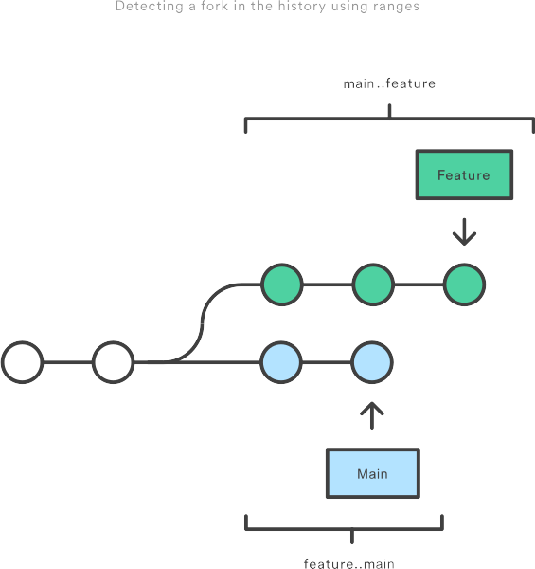
Note that if you switch the order of the range (feature..main), you will get all of the commits in main, but not in feature. If git log outputs commits for both versions, this tells you that your history has diverged.

Filtering merge commits
By default, git log includes merge commits in its output. But, if your team has an always-merge policy (that is, you merge upstream changes into topic branches instead of rebasing the topic branch onto the upstream branch), you’ll have a lot of extraneous merge commits in your project history.
You can prevent git log from displaying these merge commits by passing the --no-merges flag:
git log --no-merges
On the other hand, if you’re only interested in the merge commits, you can use the --merges flag:
git log --merges
This returns all commits that have at least two parents.

Summary

You should now be fairly comfortable using git log’s advanced parameters to format its output and select which commits you want to display. This gives you the power to pull out exactly what you need from your project history.
These new skills are an important part of your Git toolkit, but remember that git log is often used in conjunction other Git commands. Once you’ve found the commit you’re looking for, you typically pass it off to git checkout, git revert, or some other tool for manipulating your commit history. So, be sure to keep on learning about Git’s advanced features.

Git hooks
Git hooks are scripts that run automatically every time a particular event occurs in a Git repository. They let you customize Git’s internal behavior and trigger customizable actions at key points in the development life cycle.
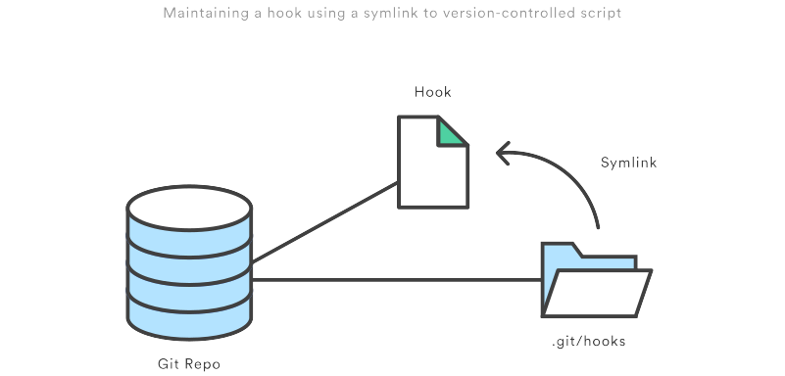
Common use cases for Git hooks include encouraging a commit policy, altering the project environment depending on the state of the repository, and implementing continuous integration workflows. But, since scripts are infinitely customizable, you can use Git hooks to automate or optimize virtually any aspect of your development workflow.
In this article, we’ll start with a conceptual overview of how Git hooks work. Then, we’ll survey some of the most popular hooks for use in both local and server-side repositories.

Conceptual overview

All Git hooks are ordinary scripts that Git executes when certain events occur in the repository. This makes them very easy to install and configure.
Hooks can reside in either local or server-side repositories, and they are only executed in response to actions in that repository. We’ll take a concrete look at categories of hooks later in this article. The configuration discussed in the rest of this section applies to both local and server-side hooks.

Installing hooks
Hooks reside in the .git/hooks directory of every Git repository. Git automatically populates this directory with example scripts when you initialize a repository. If you take a look inside .git/hooks, you’ll find the following files:
applypatch-msg.sample pre-push.sample
commit-msg.sample pre-rebase.sample
post-update.sample prepare-commit-msg.sample
pre-applypatch.sample update.sample
pre-commit.sample

related material

How to move a full Git repository
Read article

SEE SOLUTION

Learn Git with Bitbucket Cloud
Read tutorial
These represent most of the available hooks, but the .sample extension prevents them from executing by default. To “install” a hook, all you have to do is remove the .sample extension. Or, if you’re writing a new script from scratch, you can simply add a new file matching one of the above filenames, minus the .sample extension.
As an example, try installing a simple prepare-commit-msg hook. Remove the .sample extension from this script, and add the following to the file:
#!/bin/sh

echo "# Please include a useful commit message!" > $1
Hooks need to be executable, so you may need to change the file permissions of the script if you’re creating it from scratch. For example, to make sure that prepare-commit-msg is executable, you would run the following command:
chmod +x prepare-commit-msg
You should now see this message in place of the default commit message every time you run git commit. We’ll take a closer look at how this actually works in the Prepare Commit Message section. For now, let’s just revel in the fact that we can customize some of Git’s internal functionality.
The built-in sample scripts are very useful references, as they document the parameters that are passed in to each hook (they vary from hook to hook).

Scripting languages
The built-in scripts are mostly shell and PERL scripts, but you can use any scripting language you like as long as it can be run as an executable. The shebang line (#!/bin/sh) in each script defines how your file should be interpreted. So, to use a different language, all you have to do is change it to the path of your interpreter.
For instance, we can write an executable Python script in the prepare-commit-msg file instead of using shell commands. The following hook will do the same thing as the shell script in the previous section.
#!/usr/bin/env python

import sys, os

commit_msg_filepath = sys.argv[1]
with open(commit_msg_filepath, 'w') as f:
f.write("# Please include a useful commit message!")
Notice how the first line changed to point to the Python interpreter. And, instead of using $1 to access the first argument passed to the script, we used sys.argv[1] (again, more on this in a moment).
This is a very powerful feature for Git hooks because it lets you work in whatever language you’re most comfortable with.

Scope of hooks
Hooks are local to any given Git repository, and they are not copied over to the new repository when you run git clone. And, since hooks are local, they can be altered by anybody with access to the repository.
This has an important impact when configuring hooks for a team of developers. First, you need to find a way to make sure hooks stay up-to-date amongst your team members. Second, you can’t force developers to create commits that look a certain way—you can only encourage them to do so.
Maintaining hooks for a team of developers can be a little tricky because the .git/hooks directory isn’t cloned with the rest of your project, nor is it under version control. A simple solution to both of these problems is to store your hooks in the actual project directory (above the .git directory). This lets you edit them like any other version-controlled file. To install the hook, you can either create a symlink to it in .git/hooks, or you can simply copy and paste it into the .git/hooks directory whenever the hook is updated.
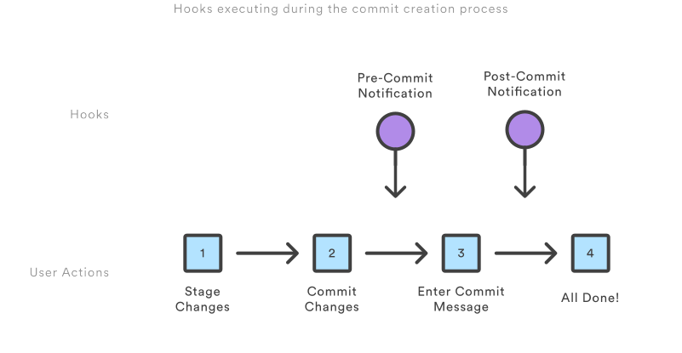
As an alternative, Git also provides a Template Directory mechanism that makes it easier to install hooks automatically. All of the files and directories contained in this template directory are copied into the .git directory every time you use git init or git clone.
All of the local hooks described below can be altered—or completely un-installed—by the owner of a repository. It’s entirely up to each team member whether or not they actually use a hook. With this in mind, it’s best to think of Git hooks as a convenient developer tool rather than a strictly enforced development policy.
That said, it is possible to reject commits that do not conform to some standard using server-side hooks. We’ll talk more about this later in the article.

Local hooks

Local hooks affect only the repository in which they reside. As you read through this section, remember that each developer can alter their own local hooks, so you can’t use them as a way to enforce a commit policy. They can, however, make it much easier for developers to adhere to certain guidelines. In this section, we’ll be exploring 6 of the most useful local hooks:
- pre-commit
- prepare-commit-msg
- commit-msg
- post-commit
- post-checkout
- pre-rebase
The first 4 hooks let you plug into the entire commit life cycle, and the final 2 let you perform some extra actions or safety checks for the git checkout and git rebase commands, respectively.
All of the pre- hooks let you alter the action that’s about to take place, while the post- hooks are used only for notifications.
We’ll also see some useful techniques for parsing hook arguments and requesting information about the repository using lower-level Git commands.

Pre-Commit
The pre-commit script is executed every time you run git commit before Git asks the developer for a commit message or generates a commit object. You can use this hook to inspect the snapshot that is about to be committed. For example, you may want to run some automated tests that make sure the commit doesn’t break any existing functionality.
No arguments are passed to the pre-commit script, and exiting with a non-zero status aborts the entire commit. Let’s take a look at a simplified (and more verbose) version of the built-in pre-commit hook. This script aborts the commit if it finds any whitespace errors, as defined by the git diff-index command (trailing whitespace, lines with only whitespace, and a space followed by a tab inside the initial indent of a line are considered errors by default).
#!/bin/sh

# Check if this is the initial commit
if git rev-parse --verify HEAD >/dev/null 2>&1
then
echo "pre-commit: About to create a new commit..."
against=HEAD
else
echo "pre-commit: About to create the first commit..."
against=4b825dc642cb6eb9a060e54bf8d69288fbee4904
fi

# Use git diff-index to check for whitespace errors
echo "pre-commit: Testing for whitespace errors..."
if ! git diff-index --check --cached $against
then
echo "pre-commit: Aborting commit due to whitespace errors"
exit 1
else
echo "pre-commit: No whitespace errors :)"
exit 0
fi
In order to use git diff-index, we need to figure out which commit reference we’re comparing the index to. Normally, this is HEAD; however, HEAD doesn’t exist when creating the initial commit, so our first task is to account for this edge case. We do this with git rev-parse --verify, which simply checks whether or not the argument (HEAD) is a valid reference. The >/dev/null 2>&1 portion silences any output from git rev-parse. Either HEAD or an empty commit object is stored in the against variable for use with git diff-index. The 4b825d... hash is a magic commit ID that represents an empty commit.
The git diff-index --cached command compares a commit against the index. By passing the --check option, we’re asking it to warn us if the changes introduces whitespace errors. If it does, we abort the commit by returning an exit status of 1, otherwise we exit with 0 and the commit workflow continues as normal.
This is just one example of the pre-commit hook. It happens to use existing Git commands to run tests on the changes introduced by the proposed commit, but you can do anything you want in pre-commit including executing other scripts, running a 3rd-party test suite, or checking code style with Lint.

Prepare commit message
The prepare-commit-msg hook is called after the pre-commit hook to populate the text editor with a commit message. This is a good place to alter the automatically generated commit messages for squashed or merged commits.
One to three arguments are passed to the prepare-commit-msg script:
1. The name of a temporary file that contains the message. You change the commit message by altering this file in-place.
2. The type of commit. This can be message (-m or -F option), template (-t option), merge (if the commit is a merge commit), or squash (if the commit is squashing other commits).
3. The SHA1 hash of the relevant commit. Only given if -c, -C, or --amend option was given.
As with pre-commit, exiting with a non-zero status aborts the commit.
We already saw a simple example that edited the commit message, but let’s take a look at a more useful script. When using an issue tracker, a common convention is to address each issue in a separate branch. If you include the issue number in the branch name, you can write a prepare-commit-msg hook to automatically include it in each commit message on that branch.
#!/usr/bin/env python

import sys, os, re
from subprocess import check_output

# Collect the parameters
commit_msg_filepath = sys.argv[1]
if len(sys.argv) > 2:
commit_type = sys.argv[2]
else:
commit_type = ''
if len(sys.argv) > 3:
commit_hash = sys.argv[3]
else:
commit_hash = ''

print "prepare-commit-msg: File: %s\nType: %s\nHash: %s" % (commit_msg_filepath, commit_type, commit_hash)

# Figure out which branch we're on
branch = check_output(['git', 'symbolic-ref', '--short', 'HEAD']).strip()
print "prepare-commit-msg: On branch '%s'" % branch

# Populate the commit message with the issue #, if there is one
if branch.startswith('issue-'):
print "prepare-commit-msg: Oh hey, it's an issue branch."
result = re.match('issue-(.*)', branch)
issue_number = result.group(1)

with open(commit_msg_filepath, 'r+') as f:
content = f.read()
f.seek(0, 0)
f.write("ISSUE-%s %s" % (issue_number, content))
First, the above prepare-commit-msg hook shows you how to collect all of the parameters that are passed to the script. Then, it calls git symbolic-ref --short HEAD to get the branch name that corresponds to HEAD. If this branch name starts with issue-, it re-writes the commit message file contents to include the issue number in the first line. So, if your branch name is issue-224, this will generate the following commit message.
ISSUE-224

# Please enter the commit message for your changes. Lines starting
# with '#' will be ignored, and an empty message aborts the commit.
# On branch issue-224
# Changes to be committed:
# modified: test.txt
One thing to keep in mind when using prepare-commit-msg is that it runs even when the user passes in a message with the -m option of git commit. This means that the above script will automatically insert the ISSUE-[#] string without letting the user edit it. You can handle this case by seeing if the 2nd parameter (commit_type) is equal to message.
However, without the -m option, the prepare-commit-msg hook does allow the user to edit the message after its generated, so this is really more of a convenience script than a way to enforce a commit message policy. For that, you need the commit-msg hook discussed in the next section.

Commit message
The commit-msg hook is much like the prepare-commit-msg hook, but it’s called after the user enters a commit message. This is an appropriate place to warn developers that their message doesn’t adhere to your team’s standards.
The only argument passed to this hook is the name of the file that contains the message. If it doesn’t like the message that the user entered, it can alter this file in-place (just like with prepare-commit-msg) or it can abort the commit entirely by exiting with a non-zero status.
For example, the following script checks to make sure that the user didn’t delete the ISSUE-[#] string that was automatically generated by the prepare-commit-msg hook in the previous section.
#!/usr/bin/env python

import sys, os, re
from subprocess import check_output

# Collect the parameters
commit_msg_filepath = sys.argv[1]

# Figure out which branch we're on
branch = check_output(['git', 'symbolic-ref', '--short', 'HEAD']).strip()
print "commit-msg: On branch '%s'" % branch

# Check the commit message if we're on an issue branch
if branch.startswith('issue-'):
print "commit-msg: Oh hey, it's an issue branch."
result = re.match('issue-(.*)', branch)
issue_number = result.group(1)
required_message = "ISSUE-%s" % issue_number

with open(commit_msg_filepath, 'r') as f:
content = f.read()
if not content.startswith(required_message):
print "commit-msg: ERROR! The commit message must start with '%s'" % required_message
sys.exit(1)
While this script is called every time the user creates a commit, you should avoid doing much outside of checking the commit message. If you need to notify other services that a snapshot was committed, you should use the post-commit hook instead.

Post-Commit
The post-commit hook is called immediately after the commit-msg hook. It can’t change the outcome of the git commit operation, so it’s used primarily for notification purposes.
The script takes no parameters and its exit status does not affect the commit in any way. For most post-commit scripts, you’ll want access to the commit that was just created. You can use git rev-parse HEAD to get the new commit’s SHA1 hash, or you can use git log -1 HEAD to get all of its information.
For example, if you want to email your boss every time you commit a snapshot (probably not the best idea for most workflows), you could add the following post-commit hook.
#!/usr/bin/env python

import smtplib
from email.mime.text import MIMEText
from subprocess import check_output

# Get the git log --stat entry of the new commit
log = check_output(['git', 'log', '-1', '--stat', 'HEAD'])

# Create a plaintext email message
msg = MIMEText("Look, I'm actually doing some work:\n\n%s" % log)

msg['Subject'] = 'Git post-commit hook notification'
msg['From'] = 'mary@example.com'
msg['To'] = 'boss@example.com'

# Send the message
SMTP_SERVER = 'smtp.example.com'
SMTP_PORT = 587

session = smtplib.SMTP(SMTP_SERVER, SMTP_PORT)
session.ehlo()
session.starttls()
session.ehlo()
session.login(msg['From'], 'secretPassword')

session.sendmail(msg['From'], msg['To'], msg.as_string())
session.quit()
It’s possible to use post-commit to trigger a local continuous integration system, but most of the time you’ll want to be doing this in the post-receive hook. This runs on the server instead of the user’s local machine, and it also runs every time any developer pushes their code. This makes it a much more appropriate place to perform your continuous integration.

Post-Checkout
The post-checkout hook works a lot like the post-commit hook, but it’s called whenever you successfully check out a reference with git checkout. This is nice for clearing out your working directory of generated files that would otherwise cause confusion.
This hook accepts three parameters, and its exit status has no affect on the git checkout command.
1. The ref of the previous HEAD
2. The ref of the new HEAD
3. A flag telling you if it was a branch checkout or a file checkout. The flag will be 1 and 0, respectively.
A common problem with Python developers occurs when generated .pyc files stick around after switching branches. The interpreter sometimes uses these .pyc instead of the .py source file. To avoid any confusion, you can delete all .pyc files every time you check out a new branch using the following post-checkout script:
#!/usr/bin/env python

import sys, os, re
from subprocess import check_output

# Collect the parameters
previous_head = sys.argv[1]
new_head = sys.argv[2]
is_branch_checkout = sys.argv[3]

if is_branch_checkout == "0":
print "post-checkout: This is a file checkout. Nothing to do."
sys.exit(0)

print "post-checkout: Deleting all '.pyc' files in working directory"
for root, dirs, files in os.walk('.'):
for filename in files:
ext = os.path.splitext(filename)[1]
if ext == '.pyc':
os.unlink(os.path.join(root, filename))
The current working directory for hook scripts is always set to the root of the repository, so the os.walk('.') call iterates through every file in the repository. Then, we check its extension and delete it if it’s a .pyc file.
You can also use the post-checkout hook to alter your working directory based on which branch you have checked out. For example, you might use a plugins branch to store all of your plugins outside of the core codebase. If these plugins require a lot of binaries that other branches do not, you can selectively build them only when you’re on the plugins branch.

Pre-Rebase
The pre-rebase hook is called before git rebase changes anything, making it a good place to make sure something terrible isn’t about to happen.
This hook takes 2 parameters: the upstream branch that the series was forked from, and the branch being rebased. The second parameter is empty when rebasing the current branch. To abort the rebase, exit with a non-zero status.
For example, if you want to completely disallow rebasing in your repository, you could use the following pre-rebase script:
#!/bin/sh

# Disallow all rebasing
echo "pre-rebase: Rebasing is dangerous. Don't do it."
exit 1
Now, every time you run git rebase, you’ll see this message:
pre-rebase: Rebasing is dangerous. Don't do it.
The pre-rebase hook refused to rebase.
For a more in-depth example, take a look at the included pre-rebase.sample script. This script is a little more intelligent about when to disallow rebasing. It checks to see if the topic branch that you’re trying to rebase has already been merged into the next branch (which is assumed to be the mainline branch). If it has, you’re probably going to get into trouble by rebasing it, so the script aborts the rebase.

Server-side hooks

Server-side hooks work just like local ones, except they reside in server-side repositories (e.g., a central repository, or a developer’s public repository). When attached to the official repository, some of these can serve as a way to enforce policy by rejecting certain commits.
There are 3 server-side hooks that we’ll be discussing in the rest of this article:
- pre-receive
- update
- post-receive
All of these hooks let you react to different stages of the git push process.
The output from server-side hooks are piped to the client’s console, so it’s very easy to send messages back to the developer. But, you should also keep in mind that these scripts don’t return control of the terminal until they finish executing, so you should be careful about performing long-running operations.

Pre-Receive
The pre-receive hook is executed every time somebody uses git push to push commits to the repository. It should always reside in the remote repository that is the destination of the push, not in the originating repository.
The hook runs before any references are updated, so it’s a good place to enforce any kind of development policy that you want. If you don’t like who is doing the pushing, how the commit message is formatted, or the changes contained in the commit, you can simply reject it. While you can’t stop developers from making malformed commits, you can prevent these commits from entering the official codebase by rejecting them with pre-receive.
The script takes no parameters, but each ref that is being pushed is passed to the script on a separate line on standard input in the following format:
<old-value> <new-value> <ref-name>
You can see how this hook works using a very basic pre-receive script that simply reads in the pushed refs and prints them out.
#!/usr/bin/env python

import sys
import fileinput

# Read in each ref that the user is trying to update
for line in fileinput.input():
print "pre-receive: Trying to push ref: %s" % line

# Abort the push
# sys.exit(1)
Again, this is a little different than the other hooks because information is passed to the script via standard input instead of as command-line arguments. After placing the above script in the .git/hooks directory of a remote repository and pushing the main branch, you’ll see something like the following in your console:
b6b36c697eb2d24302f89aa22d9170dfe609855b 85baa88c22b52ddd24d71f05db31f4e46d579095 refs/heads/main
You can use these SHA1 hashes, along with some lower-level Git commands, to inspect the changes that are going to be introduced. Some common use cases include:
- Rejecting changes that involve an upstream rebase
- Preventing non-fast-forward merges
- Checking that the user has the correct permissions to make the intended changes (mostly used for centralized Git workflows)
If multiple refs are pushed, returning a non-zero status from pre-receive aborts all of them. If you want to accept or reject branches on a case-by-case basis, you need to use the update hook instead.

Update
The update hook is called after pre-receive, and it works much the same way. It’s still called before anything is actually updated, but it’s called separately for each ref that was pushed. That means if the user tries to push 4 branches, update is executed 4 times. Unlike pre-receive, this hook doesn’t need to read from standard input. Instead, it accepts the following 3 arguments:
1. The name of the ref being updated
2. The old object name stored in the ref
3. The new object name stored in the ref
This is the same information passed to pre-receive, but since update is invoked separately for each ref, you can reject some refs while allowing others.
#!/usr/bin/env python

import sys

branch = sys.argv[1]
old_commit = sys.argv[2]
new_commit = sys.argv[3]

print "Moving '%s' from %s to %s" % (branch, old_commit, new_commit)

# Abort pushing only this branch
# sys.exit(1)
The above update hook simply outputs the branch and the old/new commit hashes. When pushing more than one branch to the remote repository, you’ll see the print statement execute for each branch.

Post-Receive
The post-receive hook gets called after a successful push operation, making it a good place to perform notifications. For many workflows, this is a better place to trigger notifications than post-commit because the changes are available on a public server instead of residing only on the user’s local machine. Emailing other developers and triggering a continuous integration system are common use cases for post-receive.
The script takes no parameters, but is sent the same information as pre-receive via standard input.

Summary

In this article, we learned how Git hooks can be used to alter internal behavior and receive notifications when certain events occur in a repository. Hooks are ordinary scripts that reside in the .git/hooks repository, which makes them very easy to install and customize.
We also looked at some of the most common local and server-side hooks. These let us plug in to the entire development life cycle. We now know how to perform customizable actions at every stage in the commit creation process, as well as the git push process. With a little bit of scripting knowledge, this lets you do virtually anything you can imagine with a Git repository.

Git refs: An overview
Learn the basics of Git with this space themed tutorial.
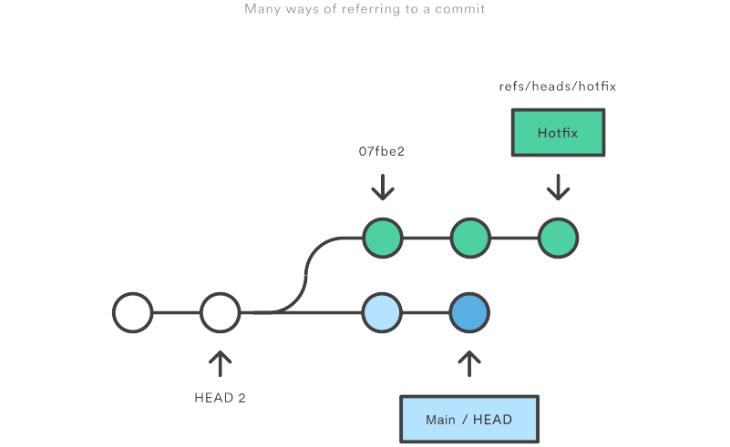
By understanding the many ways to refer to a commit, you make all of these commands that much more powerful. In this chapter, we’ll shed some light on the internal workings of common commands like git checkout, git branch, and git push by exploring the many methods of referring to a commit.
We’ll also learn how to revive seemingly “lost” commits by accessing them through Git’s reflog mechanism.

Hashes

The most direct way to reference a commit is via its SHA-1 hash. This acts as the unique ID for each commit. You can find the hash of all your commits in the git log output.
commit 0c708fdec272bc4446c6cabea4f0022c2b616eba Author: Mary Johnson Date: Wed Jul 9 16:37:42 2014 -0500 Some commit message
When passing the commit to other Git commands, you only need to specify enough characters to uniquely identify the commit. For example, you can inspect the above commit with git show by running the following command:
git show 0c708f
It’s sometimes necessary to resolve a branch, tag, or another indirect reference into the corresponding commit hash. For this, you can use the git rev-parse command. The following returns the hash of the commit pointed to by the main branch:

related material

How to move a full Git repository
Read article

SEE SOLUTION

Learn Git with Bitbucket Cloud
Read tutorial
git rev-parse main
This is particularly useful when writing custom scripts that accept a commit reference. Instead of parsing the commit reference manually, you can let git rev-parse normalize the input for you.

Refs

A ref is an indirect way of referring to a commit. You can think of it as a user-friendly alias for a commit hash. This is Git’s internal mechanism of representing branches and tags.
Refs are stored as normal text files in the .git/refs directory, where .git is usually called .git. To explore the refs in one of your repositories, navigate to .git/refs. You should see the following structure, but it will contain different files depending on what branches, tags, and remotes you have in your repo:
.git/refs/ heads/ main some-feature remotes/ origin/ main tags/ v0.9
The heads directory defines all of the local branches in your repository. Each filename matches the name of the corresponding branch, and inside the file you’ll find a commit hash. This commit hash is the location of the tip of the branch. To verify this, try running the following two commands from the root of the Git repository:
# Output the contents of `refs/heads/main` file: cat .git/refs/heads/main # Inspect the commit at the tip of the `main` branch: git log -1 main
The commit hash returned by the cat command should match the commit ID displayed by git log.
To change the location of the main branch, all Git has to do is change the contents of the refs/heads/main file. Similarly, creating a new branch is simply a matter of writing a commit hash to a new file. This is part of the reason why Git branches are so lightweight compared to SVN.
The tags directory works the exact same way, but it contains tags instead of branches. The remotes directory lists all remote repositories that you created with git remote as separate subdirectories. Inside each one, you’ll find all the remote branches that have been fetched into your repository.

Specifying refs
When passing a ref to a Git command, you can either define the full name of the ref, or use a short name and let Git search for a matching ref. You should already be familiar with short names for refs, as this is what you’re using each time you refer to a branch by name.
git show some-feature
The some-feature argument in the above command is actually a short name for the branch. Git resolves this to refs/heads/some-feature before using it. You can also specify the full ref on the command line, like so:
git show refs/heads/some-feature
This avoids any ambiguity regarding the location of the ref. This is necessary, for instance, if you had both a tag and a branch called some-feature. However, if you’re using proper naming conventions, ambiguity between tags and branches shouldn’t generally be a problem.
We’ll see more full ref names in the Refspecs section.

Packed refs

For large repositories, Git will periodically perform a garbage collection to remove unnecessary objects and compress refs into a single file for more efficient performance. You can force this compression with the garbage collection command:
git gc
This moves all of the individual branch and tag files in the refs folder into a single file called packed-refs located in the top of the .git directory. If you open up this file, you’ll find a mapping of commit hashes to refs:
00f54250cf4e549fdfcafe2cf9a2c90bc3800285 refs/heads/feature 0e25143693cfe9d5c2e83944bbaf6d3c4505eb17 refs/heads/main bb883e4c91c870b5fed88fd36696e752fb6cf8e6 refs/tags/v0.9
On the outside, normal Git functionality won’t be affected in any way. But, if you’re wondering why your .git/refs folder is empty, this is where the refs went.

Special refs

In addition to the refs directory, there are a few special refs that reside in the top-level .git directory. They are listed below:
- HEAD – The currently checked-out commit/branch.
- FETCH_HEAD – The most recently fetched branch from a remote repo.
- ORIG_HEAD – A backup reference to HEAD before drastic changes to it.
- MERGE_HEAD – The commit(s) that you’re merging into the current branch with git merge.
- CHERRY_PICK_HEAD – The commit that you’re cherry-picking.
These refs are all created and updated by Git when necessary. For example, The git pull command first runs git fetch, which updates the FETCH_HEAD reference. Then, it runs git merge FETCH_HEAD to finish pulling the fetched branches into the repository. Of course, you can use all of these like any other ref, as I’m sure you’ve done with HEAD.
These files contain different content depending on their type and the state of your repository. The HEAD ref can contain either a symbolic ref, which is simply a reference to another ref instead of a commit hash, or a commit hash. For example, take a look at the contents of HEAD when you’re on the main branch:
git checkout main cat .git/HEAD
This will output ref: refs/heads/main, which means that HEAD points to the refs/heads/main ref. This is how Git knows that the main branch is currently checked out. If you were to switch to another branch, the contents of HEAD would be updated to reflect the new branch. But, if you were to check out a commit instead of a branch, HEAD would contain a commit hash instead of a symbolic ref. This is how Git knows that it’s in a detached HEAD state.
For the most part, HEAD is the only reference that you’ll be using directly. The others are generally only useful when writing lower-level scripts that need to hook into Git’s internal workings.

Refspecs

A refspec maps a branch in the local repository to a branch in a remote repository. This makes it possible to manage remote branches using local Git commands and to configure some advanced git push and git fetch behavior.
A refspec is specified as [+]＜src＞:＜dst＞. The ＜src＞ parameter is the source branch in the local repository, and the ＜dst＞ parameter is the destination branch in the remote repository. The optional + sign is for forcing the remote repository to perform a non-fast-forward update.
Refspecs can be used with the git push command to give a different name to the remote branch. For example, the following command pushes the main branch to the origin remote repo like an ordinary git push, but it uses qa-main as the name for the branch in the origin repo. This is useful for QA teams that need to push their own branches to a remote repo.
git push origin main:refs/heads/qa-main
You can also use refspecs for deleting remote branches. This is a common situation for feature-branch workflows that push the feature branches to a remote repo (e.g., for backup purposes). The remote feature branches still reside in the remote repo after they are deleted from the local repo, so you get a build-up of dead feature branches as your project progresses. You can delete them by pushing a refspec that has an empty parameter, like so:
git push origin :some-feature
This is very convenient, since you don’t need to log in to your remote repository and manually delete the remote branch. Note that as of Git v1.7.0 you can use the --delete flag instead of the above method. The following will have the same effect as the above command:
git push origin --delete some-feature
By adding a few lines to the Git configuration file, you can use refspecs to alter the behavior of git fetch. By default, git fetch fetches all of the branches in the remote repository. The reason for this is the following section of the .git/config file:
[remote "origin"] url = https://git@github.com:mary/example-repo.git fetch = +refs/heads/*:refs/remotes/origin/*
The fetch line tells git fetch to download all of the branches from the origin repo. But, some workflows don’t need all of them. For example, many continuous integration workflows only care about the main branch. To fetch only the main branch, change the fetch line to match the following:
[remote "origin"] url = https://git@github.com:mary/example-repo.git fetch = +refs/heads/main:refs/remotes/origin/main
You can also configure git push in a similar manner. For instance, if you want to always push the main branch to qa-main in the origin remote (as we did above), you would change the config file to:
[remote "origin"] url = https://git@github.com:mary/example-repo.git fetch = +refs/heads/main:refs/remotes/origin/main push = refs/heads/main:refs/heads/qa-main
Refspecs give you complete control over how various Git commands transfer branches between repositories. They let you rename and delete branches from your local repository, fetch/push to branches with different names, and configure git push and git fetch to work with only the branches that you want.

Relative refs

You can also refer to commits relative to another commit. The ~ character lets you reach parent commits. For example, the following displays the grandparent of HEAD:
git show HEAD~2
But, when working with merge commits, things get a little more complicated. Since merge commits have more than one parent, there is more than one path that you can follow. For 3-way merges, the first parent is from the branch that you were on when you performed the merge, and the second parent is from the branch that you passed to the git merge command.
The ~ character will always follow the first parent of a merge commit. If you want to follow a different parent, you need to specify which one with the ^ character. For example, if HEAD is a merge commit, the following returns the second parent of HEAD.
git show HEAD^2
You can use more than one ^ character to move more than one generation. For instance, this displays the grandparent of HEAD (assuming it’s a merge commit) that rests on the second parent.
git show HEAD^2^1
To clarify how ~ and ^ work, the following figure shows you how to reach any commit from A using relative references. In some cases, there are multiple ways to reach a commit.
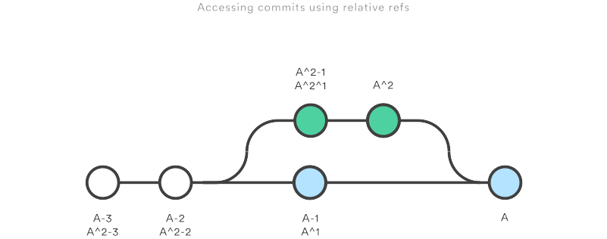
Relative refs can be used with the same commands that a normal ref can be used. For example, all of the following commands use a relative reference:
# Only list commits that are parent of the second parent of a merge commit git log HEAD^2 # Remove the last 3 commits from the current branch git reset HEAD~3 # Interactively rebase the last 3 commits on the current branch git rebase -i HEAD~3

The reflog

The reflog is Git’s safety net. It records almost every change you make in your repository, regardless of whether you committed a snapshot or not. You can think of it as a chronological history of everything you’ve done in your local repo. To view the reflog, run the git reflog command. It should output something that looks like the following:
400e4b7 HEAD@{0}: checkout: moving from main to HEAD~2 0e25143 HEAD@{1}: commit (amend): Integrate some awesome feature into `main` 00f5425 HEAD@{2}: commit (merge): Merge branch ';feature'; ad8621a HEAD@{3}: commit: Finish the feature
This can be translated as follows:
- You just checked out HEAD~2
- Before that you amended a commit message
- Before that you merged the feature branch into main
- Before that you committed a snapshot
The HEAD{} syntax lets you reference commits stored in the reflog. It works a lot like the HEAD~ references from the previous section, but the refers to an entry in the reflog instead of the commit history.
You can use this to revert to a state that would otherwise be lost. For example, lets say you just scrapped a new feature with git reset. Your reflog might look something like this:
ad8621a HEAD@{0}: reset: moving to HEAD~3 298eb9f HEAD@{1}: commit: Some other commit message bbe9012 HEAD@{2}: commit: Continue the feature 9cb79fa HEAD@{3}: commit: Start a new feature
The three commits before the git reset are now dangling, which means that there is no way to reference them—except through the reflog. Now, let’s say you realize that you shouldn’t have thrown away all of your work. All you have to do is check out the HEAD@{1} commit to get back to the state of your repository before you ran git reset.
git checkout HEAD@{1}
This puts you in a detached HEAD state. From here, you can create a new branch and continue working on your feature.

Summary

You should now be quite comfortable referring to commits in a Git repository. We learned how branches and tags were stored as refs in the .git subdirectory, how to read a packed-refs file, how HEAD is represented, how to use refspecs for advanced pushing and fetching, and how to use the relative ~ and ^ operators to traverse a branch hierarchy.
We also took a look at the reflog, which is a way to reference commits that are not available through any other means. This is a great way to recover from those little “Oops, I shouldn’t have done that” situations.
The point of all this was to be able to pick out exactly the commit that you need in any given development scenario. It’s very easy to leverage the skills you learned in this article against your existing Git knowledge, as some of the most common commands accept refs as arguments, including git log, git show, git checkout, git reset, git revert, git rebase, and many others.

Git submodules
Git submodules allow you to keep a git repository as a subdirectory of another git repository. Git submodules are simply a reference to another repository at a particular snapshot in time. Git submodules enable a Git repository to incorporate and track version history of external code.

What is a git submodule?

Often a code repository will depend upon external code. This external code can be incorporated in a few different ways. The external code can be directly copied and pasted into the main repository. This method has the downside of losing any upstream changes to the external repository. Another method of incorporating external code is through the use of a language's package management system like Ruby Gems or NPM. This method has the downside of requiring installation and version management at all places the origin code is deployed. Both of these suggested incorporation methods do not enable tracking edits and changes to the external repository.
A git submodule is a record within a host git repository that points to a specific commit in another external repository. Submodules are very static and only track specific commits. Submodules do not track git refs or branches and are not automatically updated when the host repository is updated. When adding a submodule to a repository a new .gitmodules file will be created. The .gitmodules file contains meta data about the mapping between the submodule project's URL and local directory. If the host repository has multiple submodules, the .gitmodules file will have an entry for each submodule.

When should you use a git submodule?

If you need to maintain a strict version management over your external dependencies, it can make sense to use git submodules. The following are a few best use cases for git submodules.
- When an external component or subproject is changing too fast or upcoming changes will break the API, you can lock the code to a specific commit for your own safety.
- When you have a component that isn’t updated very often and you want to track it as a vendor dependency.
- When you are delegating a piece of the project to a third party and you want to integrate their work at a specific time or release. Again this works when updates are not too frequent.

related material

How to move a full Git repository
Read article

SEE SOLUTION

Learn Git with Bitbucket Cloud
Read tutorial

Common commands for git submodules

Add git submodule
The git submodule add is used to add a new submodule to an existing repository. The following is an example that creates an empty repo and explores git submodules.
$ mkdir git-submodule-demo
$ cd git-submodule-demo/
$ git init
Initialized empty Git repository in /Users/atlassian/git-submodule-demo/.git/
This sequence of commands will create a new directory git-submodule-demo, enter that directory, and initialize it as a new repository. Next we will add a submodule to this fresh new repo.
$ git submodule add https://bitbucket.org/jaredw/awesomelibrary
Cloning into '/Users/atlassian/git-submodule-demo/awesomelibrary'...
remote: Counting objects: 8, done.
remote: Compressing objects: 100% (6/6), done.
remote: Total 8 (delta 1), reused 0 (delta 0)
Unpacking objects: 100% (8/8), done.
The git submodule add command takes a URL parameter that points to a git repository. Here we have added the awesomelibrary as a submodule. Git will immediately clone the submodule. We can now review the current state of the repository using git status...
$ git status
On branch main

No commits yet

Changes to be committed:
(use "git rm --cached <file>..." to unstage)

new file: .gitmodules
new file: awesomelibrary
There are now two new files in the repository .gitmodules and the awesomelibrary directory. Looking at the contents of .gitmodules shows the new submodule mapping
[submodule "awesomelibrary"]
path = awesomelibrary
url = https://bitbucket.org/jaredw/awesomelibrary
$ git add .gitmodules awesomelibrary/
$ git commit -m "added submodule"
[main (root-commit) d5002d0] added submodule
2 files changed, 4 insertions(+)
create mode 100644 .gitmodules
create mode 160000 awesomelibrary

Cloning git submodules
git clone /url/to/repo/with/submodules
git submodule init
git submodule update

Git submodule Init
The default behavior of git submodule init is to copy the mapping from the .gitmodules file into the local ./.git/config file. This may seem redundant and lead to questioning git submodule init usefulness. git submodule init has extend behavior in which it accepts a list of explicit module names. This enables a workflow of activating only specific submodules that are needed for work on the repository. This can be helpful if there are many submodules in a repo but they don't all need to be fetched for work you are doing.

Submodule workflows
Once submodules are properly initialized and updated within a parent repository they can be utilized exactly like stand-alone repositories. This means that submodules have their own branches and history. When making changes to a submodule it is important to publish submodule changes and then update the parent repositories reference to the submodule. Let’s continue with the awesomelibrary example and make some changes:
$ cd awesomelibrary/
$ git checkout -b new_awesome
Switched to a new branch 'new_awesome'
$ echo "new awesome file" > new_awesome.txt
$ git status
On branch new_awesome
Untracked files:
(use "git add <file>..." to include in what will be committed)

new_awesome.txt

nothing added to commit but untracked files present (use "git add" to track)
$ git add new_awesome.txt
$ git commit -m "added new awesome textfile"
[new_awesome 0567ce8] added new awesome textfile
1 file changed, 1 insertion(+)
create mode 100644 new_awesome.txt
$ git branch
main
* new_awesome
Here we have changed directory to the awesomelibrary submodule. We have created a new text file new_awesome.txt with some content and we have added and committed this new file to the submodule. Now let us change directories back to the parent repository and review the current state of the parent repo.
$ cd ..
$ git status
On branch main
Changes not staged for commit:
(use "git add <file>..." to update what will be committed)
(use "git checkout -- <file>..." to discard changes in working directory)

modified: awesomelibrary (new commits)

no changes added to commit (use "git add" and/or "git commit -a")
Executing git status shows us that the parent repository is aware of the new commits to the awesomelibrary submodule. It doesn't go into detail about the specific updates because that is the submodule repositories responsibility. The parent repository is only concerned with pinning the submodule to a commit. Now we can update the parent repository again by doing a git add and git commit on the submodule. This will put everything into a good state with the local content. If you are working in a team environment it is critical that you then git push the submodule updates, and the parent repository updates.
When working with submodules, a common pattern of confusion and error is forgetting to push updates for remote users. If we revisit the awesomelibrary work we just did, we pushed only the updates to the parent repository. Another developer would go to pull the latest parent repository and it would be pointing at a commit of awesomelibrary that they were unable to pull because we had forgotten to push the submodule. This would break the remote developers local repo. To avoid this failure scenario make sure to always commit and push the submodule and parent repository.

Conclusion

Git submodules are a powerful way to leverage git as an external dependency management tool. Weigh the pros and cons of git submodules before using them, as they are an advanced feature and may take a learning curve for team members to adopt.
https://www.atlassian.com/git/tutorials/merging-vs-rebasing

